**Kol Simcha Torah Gazette**

**For parsha Pinchas 5785**

Volume 9 Issue 42 (Whole #457) 23 Tammuz 5785/ July 19, 2025

**Printed L’illuy nishmas Nechama bas R’ Noach, a”h**

For a free subscription, please forward your request to [***keren18@juno.com***](mailto:keren18@juno.com)

***Past emails can be found on the website ShabbosStories.com under Brooklyn Torah Gazette***

**What Are Tisha B'Av**

**& the Three Weeks?**

**By** [**Rabbi Shraga Simmons**](https://aish.com/authors/48865357)

***A comprehensive overview of the customs and meaning of the Jewish national period of mourning.***

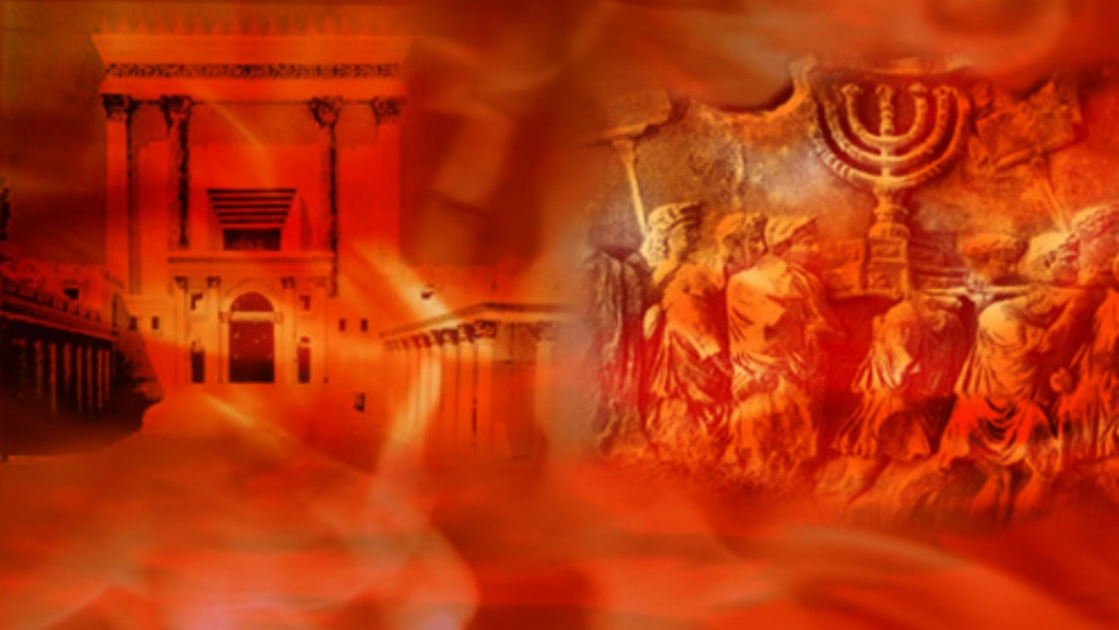

The "Three Weeks" between the 17th of Tammuz and the Tisha B'Av have historically been days of misfortune and calamity for the Jewish people. During this time, both the First and Second Temples were destroyed, amongst other tragedies.

These days are referred to as the period "within the straits"*(bein hametzarim),*in accordance with the verse: "All her oppressors have overtaken her within the straits" ([Lamentations 1:3](https://www.sefaria.org/Lamentations.1.3?lang=he-en&utm_source=aish.com&utm_medium=sefaria_linker)).

During this time, various aspects of mourning are observed by the entire nation. We minimize joy and celebration – no weddings are held, we do not listen to music, nor are there haircuts or shaving. The expressions of mourning take on greater intensity as we approach the day of Tisha B’Av.

Since the attribute of Divine judgment ("din") is acutely felt, we [avoid potentially dangerous](http://www.aish.com/h/9av/aas/48960271.html) or risky endeavors.

On Shabbat during the Three Weeks, the Haftorahs are taken from chapters in Isaiah and Jeremiah dealing with the Temple's destruction and the exile of the Jewish people.

Agonizing over these events is meant to help us conquer those spiritual deficiencies which brought about these tragic events. Through the process of "teshuva" – self-introspection and a commitment to improve – we have the power to transform tragedy into joy. In fact, the Talmud says that after the future redemption of Israel and the rebuilding of the Temple, these days will be re-dedicated as days of rejoicing and festivity.

The story is told of Napoleon walking through the streets of Paris one Tisha B'Av. As he passed a synagogue he heard the sounds of mourning and crying. "What’s this all about?" Napoleon asked. An aide explained that the Jews were in mourning the loss of their Temple. "When did this happen?" Napoleon asked. The aide replied, "About 1700 years ago." Napoleon said, "Certainly a people which has mourned the loss of their Temple for so long, will merit to see it rebuilt!"

**Seventeenth of Tammuz**

The beginning of a 3-week period of mourning is the 17th of Tammuz, a fast day commemorating the fall of Jerusalem, prior to the destruction of the Holy Temple.

On the 17th of Tammuz, no eating or drinking is permitted from the break of dawn until dusk. (Should the day coincide with Shabbat, the fast is delayed until Sunday.)

Five great catastrophes occurred in Jewish history on the 17th of Tammuz:

Moses broke the tablets at Mount Sinai – in response to the [sin of the Golden Calf](http://www.aish.com/jl/h/cc/48932377.html).

The daily offerings in the First Temple were suspended during the [siege of Jerusalem](http://www.aish.com/jl/h/cc/48937952.html), after the Kohanim could no longer obtain animals.

Jerusalem's walls were breached, prior to the [destruction of the Second Temple](http://www.aish.com/jl/h/cc/48944036.html) in 70 CE.

Prior to the Great Revolt, the Roman general Apostamos burned a Torah scroll – setting a precedent for the horrifying burning of Jewish books throughout the centuries.

An idolatrous image was placed in the Sanctuary of the Holy Temple – a brazen act of blasphemy and desecration.

**The Nine Days**

The period commencing with Rosh Chodesh Av is called the "Nine Days." During this time, a stricter level of mourning is observed, in accordance with the Talmudic dictum ([Ta'anit 26](https://www.sefaria.org/Taanit.26?lang=he-en&utm_source=aish.com&utm_medium=sefaria_linker" \t "_blank)): "When the month of Av begins, we reduce our joy."

During this time the additional "signs of mourning" include abstaining from meat and wine (except on Shabbat) and from doing laundry or wearing freshly laundered clothes (except on Shabbat). We also do not bathe for pleasure, though it is permitted to bathe in cool water in order to remove dirt or perspiration. For more details, see [“The Three Weeks.”](http://www.aish.com/h/9av/oal/48943916.html)

**Tisha B'Av – Ninth of Av**

The intensity of mourning reaches a peak on Tisha B'Av, five national calamities occurred:

During the time of Moses, Jews in the desert accepted the [slanderous report of the 12 Spies](http://www.aish.com/h/9av/ju/48945386.html), and the decree was issued forbidding them from entering the Land of Israel. (1312 BCE)

The [First Temple was destroyed](http://www.aish.com/jl/h/cc/48937952.html) by the Babylonians and Nebuchadnezzar. (586 BCE)

The [Second Temple was destroyed](http://www.aish.com/jl/h/cc/48944036.html) by the Romans. (70 CE)

[The Bar Kochba revolt](http://www.aish.com/jl/h/cc/48944706.html) was crushed by Roman Emperor Hadrian. (135 CE)

The Temple Mount was plowed under, and Jerusalem was rebuilt as a pagan city.

Other grave misfortunes throughout Jewish history coincided with the Ninth of Av, including the [expulsion from Spain in 1492](http://www.aish.com/h/9av/aas/48959116.html), the outbreak of World War One in 1914, and the mass deportation of Jews from the Warsaw Ghetto in 1942.

During the late afternoon prior to Tisha B'Av, it is customary to eat *Seudah Hamaf-seket* – a meal consisting only of bread, water and a hard-boiled egg. The food is dipped in ashes, symbolic of mourning, and eaten while seated on the ground. (The rules are somewhat different [when Tisha B'Av falls on Shabbat or Sunday](http://www.aish.com/h/9av/oal/48964976.html).)

Sundown marks the commencement of Tisha B'Av, where no eating or drinking is permitted until nightfall the following evening. It is also forbidden to bathe or wash, wear leather shoes, or engage in marital relations. We also do not learn Torah, except for texts relevant to Tisha B'Av and mourning – e.g. the book of Lamentations and Job, and certain sections of the Talmud (including the [story of Kamtza and Bar Kamtza](http://www.aish.com/h/9av/ju/48949336.html)).

The [Book of Eicha (Lamentations),](http://www.aish.com/h/9av/oal/48961756.html) Jeremiah's poetic lament over the destruction of Jerusalem and the First Temple, is read in the synagogue as part of the evening service. Special “Kinot” (elegies) are also recited, both at night and during the day.

Other mourning practices include sitting on a low chair (after midday, a regular chair permitted; see [“Laws of Shoes and Chairs”](http://www.aish.com/h/9av/oal/48964551.html)). We also minimize business and leisure activities.

Following Tisha B'Av, all normal activities may be resumed, except for the following which are delayed until midday of the 10th of Av, because the burning of the Temple [continued through the 10th of Av](http://www.aish.com/h/9av/oal/48967321.html): haircuts, washing clothes, bathing, listening to music, and eating meat and wine.

*Reprinted from the current website of aish.com*

**The Unique Mission of**

**the Jew in the World**

**By Rabbi Yoseph Geisinsky**

**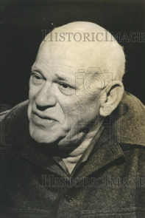**

**Eric Hoffer**

Eric Hoffer, an American social philosopher, author of the classic "The True Believer" and recipient of the Presidential Medal of Freedom, expressed Balaam's sentiments in a Los Angeles Times article decades ago.

"The Jews are a peculiar people: things permitted to other nations are forbidden to the Jews. Other nations drive out thousands, even millions of people, and there is no refugee problem. Russia did it, Poland and Czechoslovakia did it, Turkey threw out a million Greeks, and Algeria a million Frenchmen. Indonesia threw out heaven knows how many Chinese, and no one says a word about refugees. But in the case of Israel, the displaced Arabs have become eternal refugees. Everyone insists that Israel must take back every single Arab. Arnold Toynbee called the displacement of the Arabs an atrocity greater than any committed by the Nazis."

"Other nations, when victorious on the battlefield, dictate peace terms. But when Israel is victorious, it must sue for peace. Everyone expects the Jews to be the only real Christians in this world."

"Other nations, when they are defeated, survive and recover, but should Israel be defeated, it would be destroyed. Had Hamas triumphed on October 7, they would have wiped Israel off the map, and no one would have lifted a finger to save the Jews."

"No commitment to the Jews by any government, including our own, is worth the paper it is written on. There is a cry of outrage all over the world when people die in Vietnam or when two Negroes are executed in Rhodesia. But when Hitler slaughtered Jews, no one remonstrated with him. The Swedes, who are ready to break off diplomatic relations with America because of what we do in Vietnam, did not let out a peep when Hitler was slaughtering Jews. They sent Hitler choice iron ore, ball bearings, and serviced his troop trains to Norway."

"The Jews are alone in the world. Israel survives, it is solely because of Jewish efforts."

"Yet at this moment, Israel is our only reliable and unconditional ally. We can rely more on Israel than Israel can rely on us. And one has only to imagine what would have happened on October 7, had the Arabs and their Iranian backers won the war

Some years ago, in his Rosh Hashanah sermon at Temple Israel in Natick, Mass., best-selling author the late Rabbi Harold Kushner made this candid confession:

"This past year [of terrorism and anti-Semitism] has compelled me to come to conclusions I didn't want to come to. For all of my years as a rabbi, I have believed and I have taught that Jews were no different from other people, that Judaism was different from Christianity and Islam, but Jews had the same feelings, the same strengths, and weaknesses, the same fears, and dreams that Christians and Muslims have. I took issue with the Chabad rabbis who argued that Jewish souls are essentially different than gentile souls.

"I opposed and discouraged interfaith marriage, not because I believed that Jews were better than non-Jews but because a family with two religions was likely to raise children with no religion to avoid arguments."

"But this year has persuaded me that Jews are different. I find myself compelled to face the fact that the Jew plays the role for the world that the canary used to play for the coal miners. You've read about how the miners would take canaries with them into the mines because the canaries were extremely sensitive to dangerous gases. They responded to danger before the humans did. So if the miners saw the canaries get sick and pass out, they knew that the air was bad and they would escape as fast as they could.

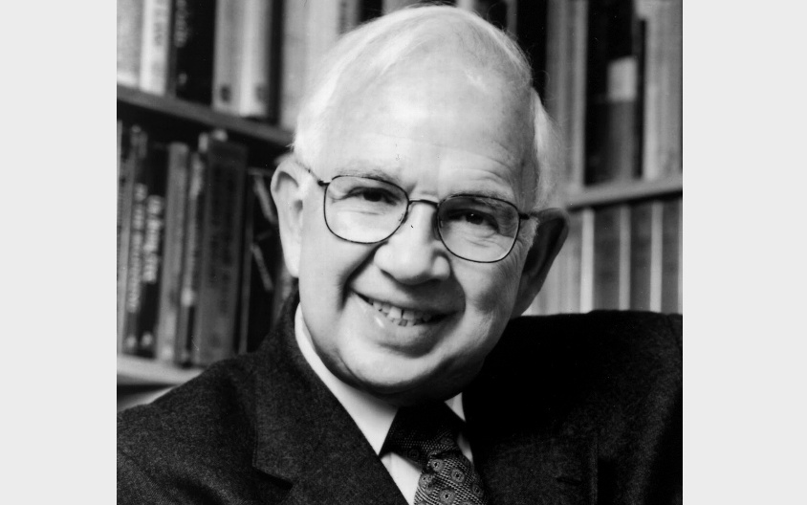

**Rabbi Harold Kushner**

"That's what we Jews do for the world. We are the world's early warning system. Where there is evil, where there is hatred, it affects us first. If there is hatred anywhere in the world, it will find us. If there is evil somewhere in the world, we will become its target. People overflowing with hatred for whatever reason, including self-hatred, make us the objects of their hatred.

"This is the role we play in the world, not by choice but imposed on us by others, to be the miner's canary, to smoke out the bigots, the haters, the people who will be a menace to their communities if someone doesn't stop them, and we identify them early on by their hatred of us.

"Hitler attacked Jews before he attacked Western civilization, and that should have alerted the world to what kind of person he was, but the world misread the signal. Muslim fanatics practiced their terrorist skills on Israelis before turning those skills on the rest of the world, but the world never understood the warning.

"Our job is to live as Jews were summoned to live, because we can't escape the fate of being a Jew. Generations before us have tried and failed. We can claim the destiny of being a Jew, because when we do that, we discover how satisfying a truly human life can be."

He said this before October 7th, and the explosion of global Jewish hatred that followed. Imagine what he would say today!

How can any rational Jew explain the fact that in our elite universities, intelligent professors and students sided with Hamas against the Jewish people? Millions were murdered in countries around the world, from Syria to Darfur, from the Congo to Ethiopia, and yet we did not hear of one demonstration. Israel is trying to avoid another Holocaust, Heaven forbid, and it is demonized?

For me, this is the great proof that the Jewish people dwell alone at the epicenter of humanity, chosen by the Creator to be ambassadors of truth, morality, love, light, and hope. So, nobody can be indifferent to Jews. Either you admire them, or you loathe them.

But why are the Jews the canaries of the world? What exactly placed the Jewish people in this position?

The very existence of the Jewish people is suggestive of another dimension of reality. As long as the Jew is around, he is a witness that G-d is around. He is the witness, whether he knows it or not, whether he consciously testifies or refuses to testify.

"His very existence, his survival, his impact, testifies to G-d's existence. That he is here, that he is present, bears witness to G-d's presence in history. There lies the origin of the satanic idea of the Final Solution. If the witness were destroyed, G-d Himself would be dead."

Many of our beloved brothers and sisters, young and old, progressive and open-minded Jews, raised in the spirit of egalitarianism and equality, have for a long time attempted to suppress this historical truth.

Yet the virulent anti-Semitism resurrected during the past decades across the world and the irrational obsession to demonize Israel, especially in the last two years tens of thousands of rockets were sent into Israel with the attempt to murder as many Jews as possible; Hamas performed a mini-Holocaust, and yet Israel is blamed! is beginning to open many of our eyes.

If you open almost any news website in the world or watch any television news station internationally, you can hear the message articulated 3,300 years ago by a sophisticated and spiritual non-Jew: "It is a people that dwells alone, and is not reckoned among the nations."

This is not a curse. It is a privilege, and it is a reality. We are the Divine ambassadors of love, light, hope, and truth. If we wish to thrive, we must embrace this truth, acknowledged long ago by our fellow non-Jews. The world is embarrassed by Jews who are embarrassed by themselves; the world respects Jews who respect themselves. The world is ashamed of an Israel that is apologetic about its 4,000-year faith and tradition that the Holy Land is G-d's gift to the Jews.

Only when we acknowledge our "aloneness" will we become a true source of blessing to all of humanity.

*Reprinted from the Parshat Balak 5758 email of the Chabad of Great Neck newsletter.*

**Thoughts that Count**

*My sacrifice... you shall observe to offer to me in its time.* (Num. 28:2)

The Hebrew word used for "observe" is often used to imply hopeful anticipation of a future happening. Though we do not have the opportunity to observe the laws of sacrifice while in exile, our constant anticipation and hope for the rebuilding of the Temple gives us a portion in the sacrifices which were previously offered there. *(Sefat Emet)*

*It is a continual burnt offering which was offered at Sinai* (Num. 28:6)

A continual burnt-offering hints to the "hidden love" which every Jew has. This love is continuous, it never ceases. *(Ohr HaTorah)*

*Let the L-rd, G-d of all living souls, appoint a man over the congregation (Num. 27:16)*

Such was Moses' plea before G-d: Our Father, as You are the G-d of all living souls-to the righteous and evil alike-so may You please grant Your people a leader who will deal fairly with "all living souls" who will love each Jew equally. *(Rabbi Levi Yitzchak of Berditchev)*

*The land shall be divided by lot*. (Num. 26:55)

The Land of Israel has different areas: mountains, valleys, fields, orchards, etc. When one person received his share in the mountains and another person in a valley, or one received cornfields and another orchards, this division of the physical Land of Israel reflected the person's individual relationship to the spiritual Land of Israel. This means that everyone has something unique that relates specifically to him or her in his spiritual service. *(Likutei Sichot)*

*And G-d said... take the sum of all the congregation of the Children of Israel from twenty years and upward* (Num. 26:1,2)

The Midrash explains that the Jewish people are counted in nine places in Scripture; the tenth and final census will be taken in the Messianic Era. This will be done either by Moshiach, according to the Aramaic translation and commentary of Rabbi Yonatan ben Uziel, or by G-d Himself, according to the Midrash.

*(Lubavitcher Rebbe, Shabbat Parshat Chukat 5750)*

*Reprinted from the Bamidbar 5762/2002 edition of L’Chaim*

**Rav Avigdor Miller on How**

**Does One Avoid Getting Cancer?**

**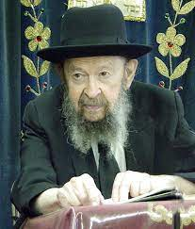**

Every day one should do what the Gemara recommends:– A person should always plead for mercy from Hashem that he shouldn’t get sick (Shabbos 32a). Which means that every day you should pray for good health. Every single day of your life! Don’t rely on Shemoneh Esrei – you don’t even think what you’re saying. It can be done outside of Shemoneh Esrei, or if you wish, you can add it when you finish Shemoneh Esrei, before you take three steps back. Beg Hakadosh Baruch Hu! Although you’ve prayed all your prayers by rote, by stereotype, like a record; but when you’ve finished, at least one little thing say with kavanah.

Now, I know you won’t do it, but listen to me anyhow. Say, “Please guard my health and my well-being.” means, “Guard me against automobile accidents and other accidents.” You have to pray always to be saved from sickness and accidents.

What do people expect, that Hakadosh Baruch Hu is going to protect them for nothing? The reason there are sicknesses and accidents in the world—far away from us— is to be a spur, to incite us to pray, to come close to Him. But if you don’t pray, so what can He do? He might have to send an accident closer to home, chalilah, to make you aware.

So therefore, always!– Every person, man and woman, boy and girl, should always seek mercy from Hashem,– not to be sick. And that’s one of the most important pieces of counsel you will ever hear.

*Reprinted from a recent email of Toras Avigdor based on a Thursday night lecture (July 2000)*

**Every Jew’s Unique**

**Spiritual Portion**

**From the Teachings of the Lubavitcher Rebbe**

**Rabbi Menachem Mendel Schneerson, Zt”l**

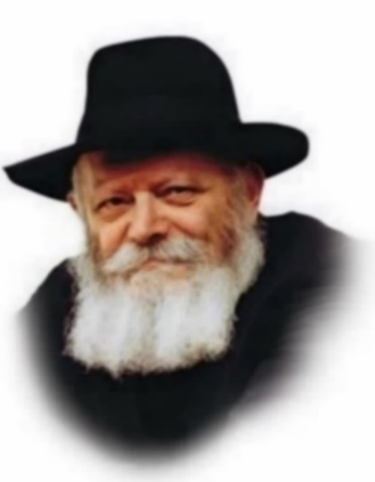

This week's Torah portion, Pinchas, describes the apportionment of the Land of Israel. The Torah states, "Through the lot shall the land be divided." The Talmud notes that the process by which the lots were drawn was not random; the miraculous Urim and Tumim, in the breastplate of the High Priest, guided the outcome.

The famous commentator Rashi explains that not only was the portion of the Holy Land to be given to each tribe written on the lot picked for that tribe, but the lot itself spoke and announced the result. In other words, the division of the soon-to-be conquered Land of Israel was determined by G-d Himself.

The inheritance of the physical portion of land is symbolic of the spiritual inheritance of every Jew with which he is enjoined to fulfill his individual mission in life. Just as each of the Twelve Tribes was given a specific portion of land to live in and cultivate, every Jew is allotted his own spiritual realm to perfect.

Although a person might think he is free to choose his own spiritual portion, following whichever path in the service of G-d that appeals to his nature, the Torah teaches that this is not a matter of free will or logic, but is ordained by G-d.

Every Jewish soul has its own particular inclinations and disinclinations; some mitzvot (commandments) are easier to observe than others. The Talmud notes that many of our Sages were especially careful in their performance of one particular commandment. Although they certainly observed all 613 of the Torah's mitzvot, their performance of that one mitzva was especially praiseworthy. The exemplary observance of that one mitzva served as the conduit through which all other mitzvot flowed.

A person cannot choose his own spiritual bent; it is an integral part of his individual spiritual makeup. But how does one determine exactly which mitzvot are especially relevant to him? By objectively ascertaining those which he finds the hardest to do!

A person may safely assume that a given direction is his "inheritance" whenever the path seems strewn with obstacles and hindrances. In fact, the more important the mitzva, the harder the Evil Inclination tries to dissuade the person.

A lack of interest in a particular facet of Torah study or indifference to a certain mitzva indicates that it is precisely in these areas that special efforts must be made. In the merit of this effort, G-d grants the individual success in all other areas of his life as well.

*Reprinted from the Pinchas 5762/2002 edition of L’Chaim. Adapted from the works of the Lubavitcher Rebbe.*

**How an Italian Girl Found Faith, Family, and Fashion in Judaism**

**By** [**Aja Cohen**](https://www.chabad.org/search/keyword_cdo/kid/32753/jewish/Cohen-Aja.htm)

If you had told my younger self—raised in a traditional Italian Catholic home surrounded by pasta, strong family ties, and church on Sundays—that one day I'd be keeping Shabbat, living in Teaneck, NJ, and running a modest activewear brand, I wouldn't have believed you.

I was raised in a loving Italian Catholic family where food, family, and tradition were everything. In many ways, it wasn't so different from Jewish life—I just didn't know it yet.

But G‑d’s plans are bigger than our imagination.

My first real introduction to Jewish life came through a boyfriend I was dating in my early twenties. He was Israeli, from Great Neck, Long Island, and very upfront that marriage wasn't an option for us. Still, when he invited me to join him for Shabbat dinner, I said yes.

I didn't know it at the time, but that evening would plant the seed for everything that came next.

There was something deeply familiar in the experience—the way everyone gathered around the table, the importance of family, the joy in sharing a meal. It reminded me of my Italian upbringing, just with blessings and candles instead of rosaries.

I wanted to understand more.

I remember walking into a bookstore and picking up my first book on Judaism. I didn't know where this journey would lead, but I knew I wanted to follow it.

On Rosh Hashanah, I asked to attend services. We ended up at a Sephardic Orthodox synagogue. I didn't understand everything being said, but something clicked inside me. For the first time, I felt spiritually seen.

While studying fashion at Pratt, I joined a “Kabbalah & Sushi” night hosted by the Chabad rabbi on campus, Rabbi Simcha Weinstein. One class turned into many, and I began to learn more about Judaism from Rabbi Ari Raskin.

Not long after, I met my husband, Evan, at a Yom Kippur service in Brooklyn. From the outset, our connection was rooted in wanting to grow—together. We both wanted to build a home based on Jewish law and Torah observance and I chose to undergo an Orthodox conversion. It was a commitment, but one I embraced with my whole heart.

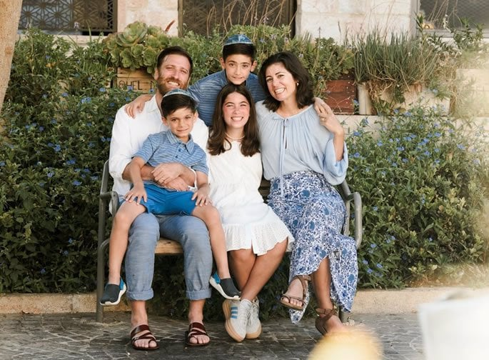

We married, started our family in Park Slope, and eventually moved to Teaneck. What I once jokingly called “the Jewish ghetto” became our spiritual home. It's where we've built our life, raised our kids, and found our people.

In the midst of all this, I was working in corporate fashion, designing fast-paced collections for big athletic brands. But as my lifestyle changed, my values did too. I started asking myself: What am I creating and who am I creating it for?

During the pandemic, I stepped back—and that's when inspiration struck. Living in Teaneck, I saw women walking, running, and pushing strollers—all while dressed in skirts, long sleeves, and leggings. Modesty wasn't holding anyone back. But the options? They weren't great. I knew I could bring my design background, my passion for movement, and my love of *tzniut*together to create something better.

So, I decided to start my own company (Transcendent Active). Today, thank [G‑d](https://www.chabad.org/library/article_cdo/aid/433240/jewish/God.htm), we have a full line of clothing that helps women move with confidence and dignity.

I started this for the women around me—women embracing modesty in all stages of life. But in the process, I found my own voice: To me, modesty isn't about hiding. It's about showing up fully—with intention, pride, and purpose.

*Reprinted from the current website of Chabad.Org*

**A Shepherd for Klal Yisroel, Not for Oneself:**

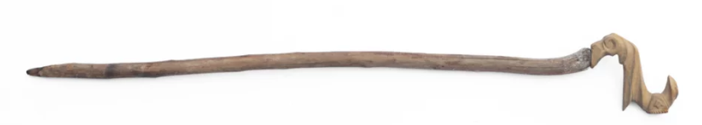

The Kesav Sofer zt”l explains that when most shepherds tend their flocks of sheep, they are really worried about themselves. Their actual goal is to earn money by selling the wool and meat of the sheep. If they would find themselves and their flock in danger, they would abandon the sheep and just try to save themselves.

A “shepherd of Yisroel”, however, is not like that. A Jewish leader must be prepared to sacrifice himself for the good of the people. He must not abandon them in the face of danger. Rather, he must protect them at all costs – even if it places his own life at risk.

Moshe was saying that Klal Yisroel should not be like sheep who do not have a shepherd when times get tough, because the shepherd runs away to save himself and leaves the sheep alone. Rather, their shepherd should stay to protect them even when they are threatened by danger.

*Reprinted from the Pinchas 5785 email of The Way of Emunah: Collected Thoughts on the Weekly Parshah from Rabbi Meir Isamar Rosenbaum.*